A Report on

Educational Institutions Management & Monitoring System

Class and Collaboration Diagram

Name Student ID

* + - Kamrul Hasan Shourov 1005097
    - Mahabub Zoraf 1005106
    - Aminul Haque Ripon 1005107
    - Md. Bulbul Sharif 1005108
    - Ashif Salman Rupsha 1005109

Date: 25 JAN, 2014

**Contents**

Section Page Number

1. Class and Collaboration Diagrams of the subsystems
   1. Registration for Primary School Certificate Examination…………..3
   2. Monitoring Student’s Performance………………………....7
   3. Monitoring Teacher’s Performance ……………………….13
   4. Monitoring Institution’s Performance……………………..18
   5. Book Distribution………………………………………….26

Sub System: Registration for Primary School Certificate Examination

Use Case: Starting Online Registration

Class Diagram:

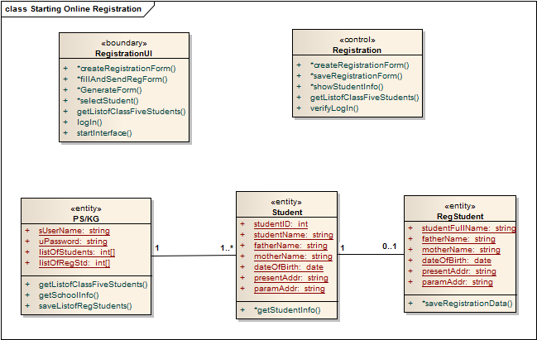

Collaboration Diagram: 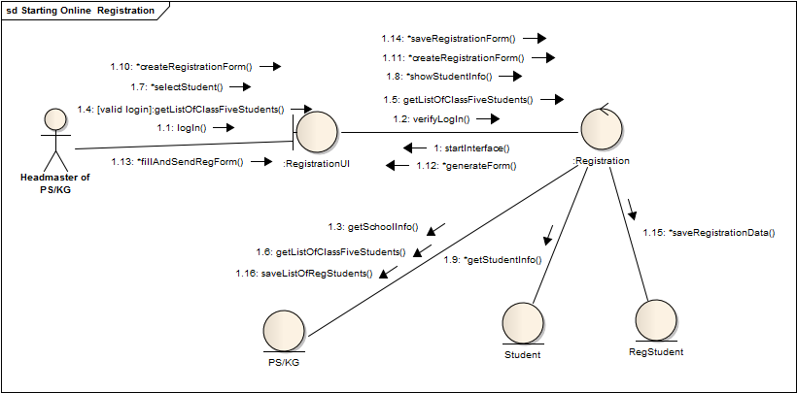

Sub System: Registration for Primary School Certificate Examination

Use Case: Checking Registration Info

Class Diagram:

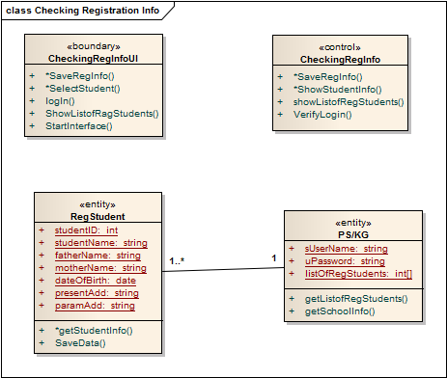

Collaboration Diagram:

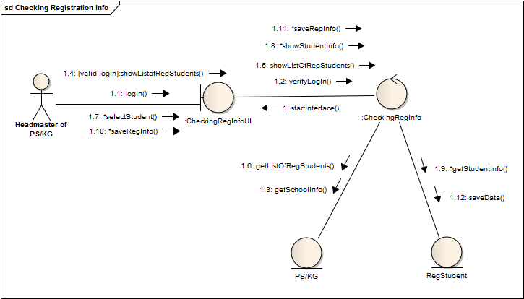

Sub System: Monitoring Student’s Performance

Use Case: Analyzing Student’s Profile

Class Diagram:

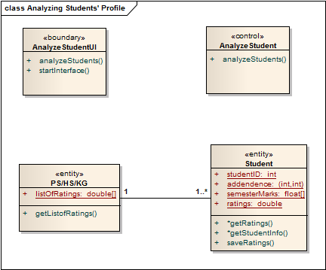

Collaboration Diagram:

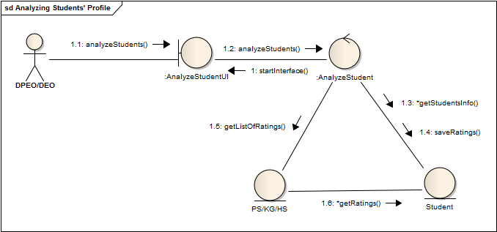

Sub System: Monitoring Student’s Performance

Use Case: Student’s Performance Monitoring and Taking Proper Steps

Class Diagram:

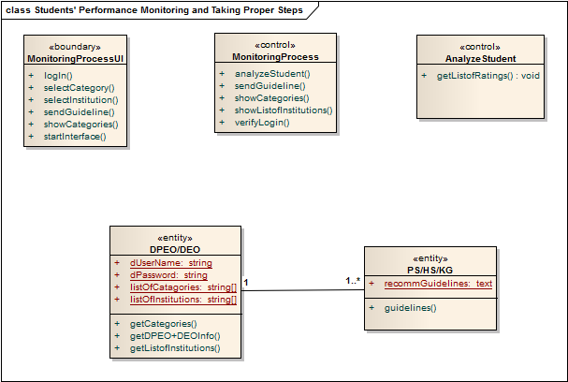

Collaboration Diagram:

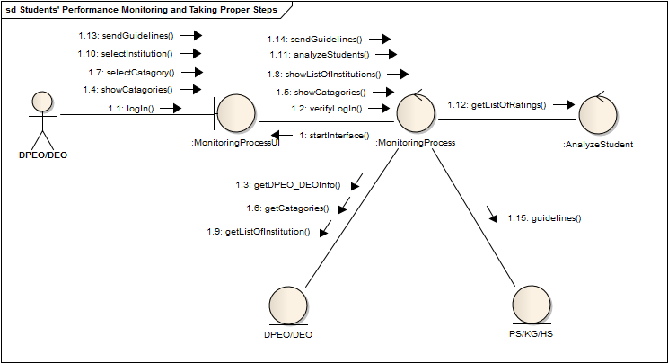

Sub System: Monitoring Student’s Performance

Use Case: Updating Student’s Profile

Class Diagram:

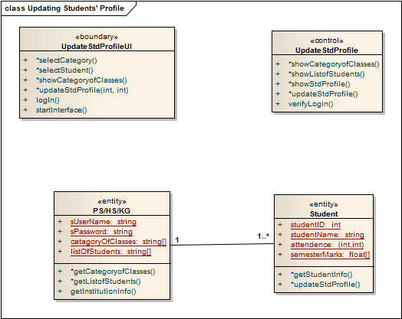

Collaboration Diagram:

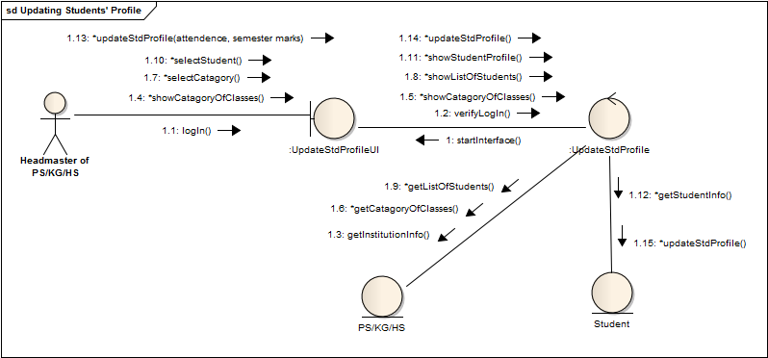

Sub System: Monitoring Teacher’s Performance

Use Case: Analyzing Teacher’s Profile

Class Diagram:

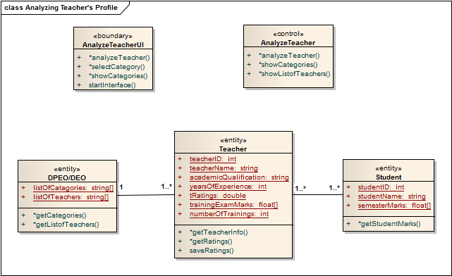

Collaboration Diagram:

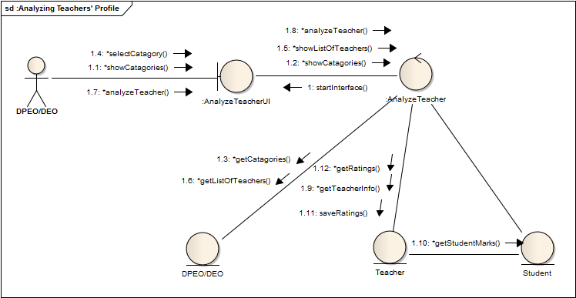

Sub System: Monitoring Teacher’s Performance

Use Case: Training Sessions

Class Diagram:

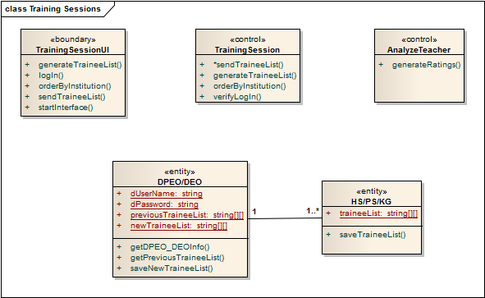

Collaboration Diagram:

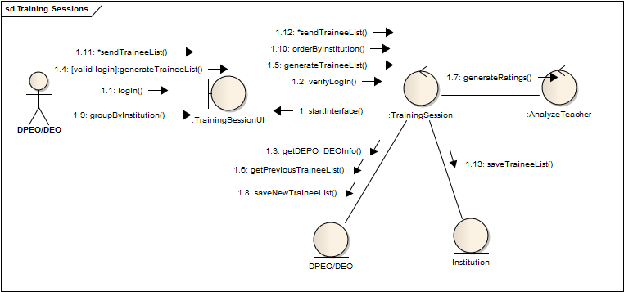

Sub System: Monitoring Teacher’s Performance

Use Case: Update Trainee’s Profile

Class Diagram:

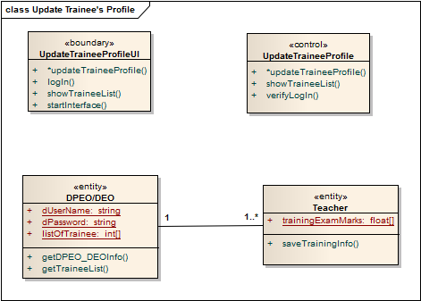

Collaboration Diagram:

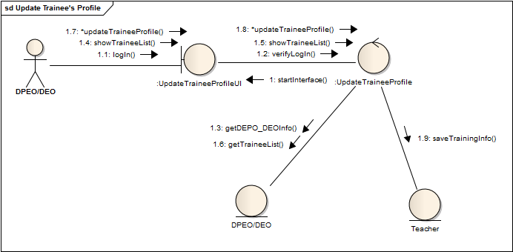

Sub System: Monitoring Institution’s Performance

Use Case: Analyzing Institution’s Profile

Class Diagram:

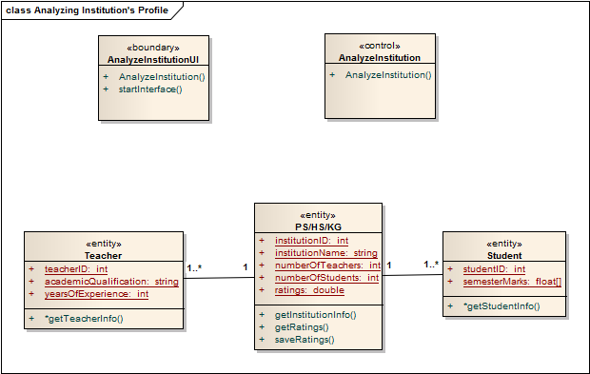

Collaboration Diagram:

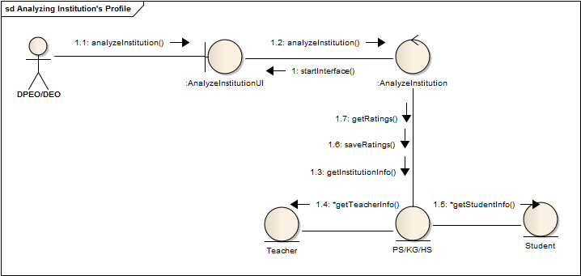

Sub System: Monitoring Institution’s Performance

Use Case: Create New Student’s Profile

Class Diagram:

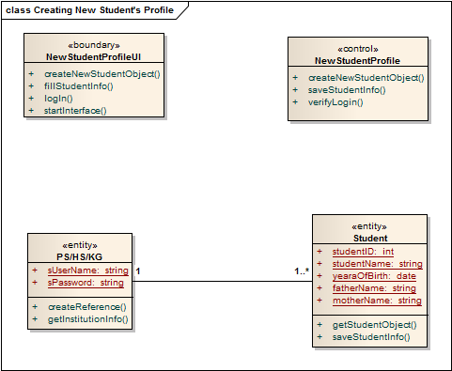

Collaboration Diagram:

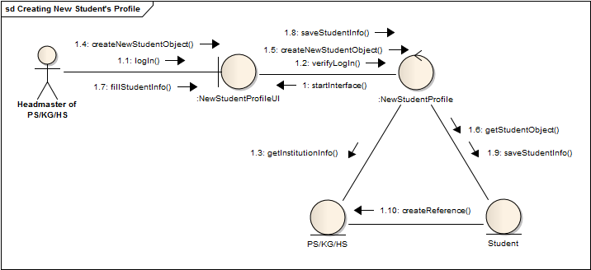

Sub System: Monitoring Institution’s Performance

Use Case: Create New Teacher’s Profile

Class Diagram:

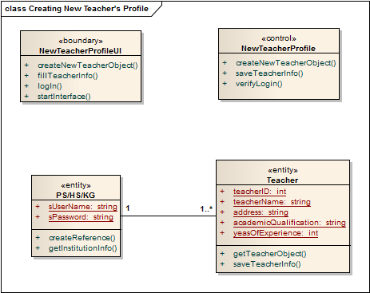

Collaboration Diagram:

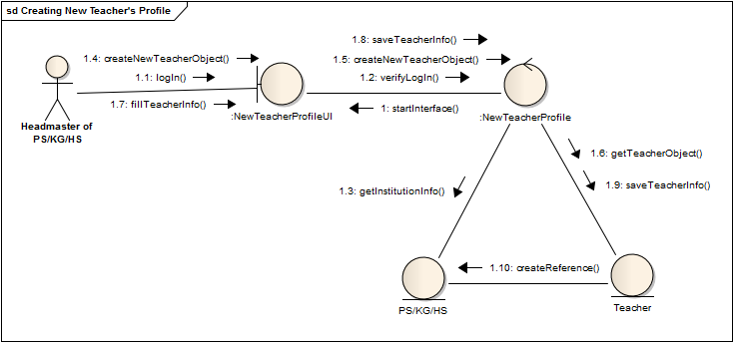

Sub System: Monitoring Institution’s Performance

Use Case: Institution’s Performance Monitoring and Taking Proper Steps

Class Diagram:

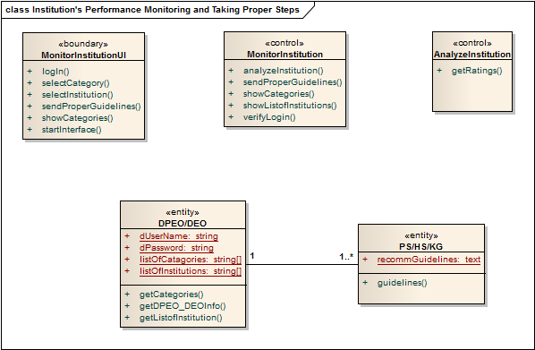

Collaboration Diagram:

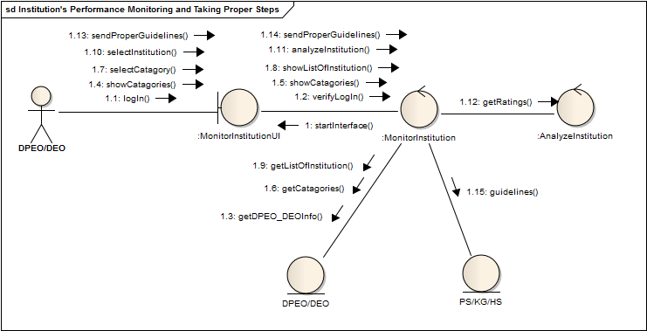

Sub System: Book Distribution

Use Case: Calculating Total Number of Students

Class Diagram:

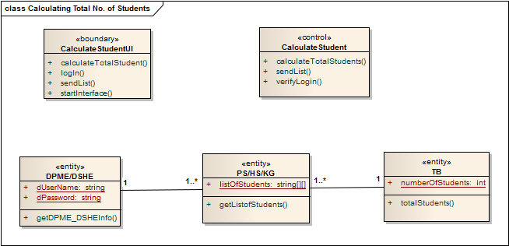

Collaboration Diagram:

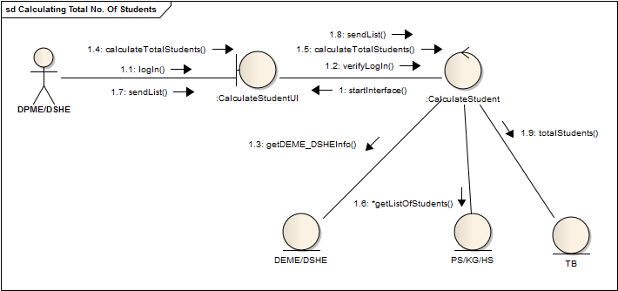

Sub System: Book Distribution

Use Case: Monitoring Book Distribution Process

Class Diagram:

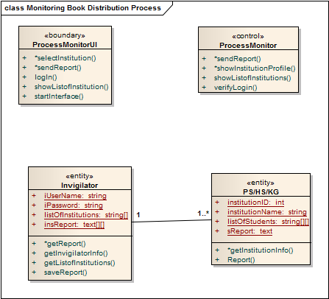

Collaboration Diagram:

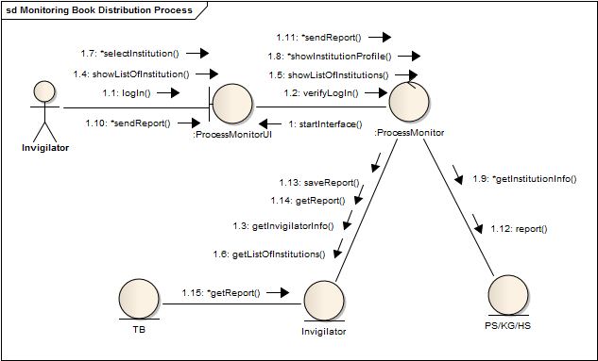

Sub System: Book Distribution

Use Case: Scheduling Book Distribution Process

Class Diagram:

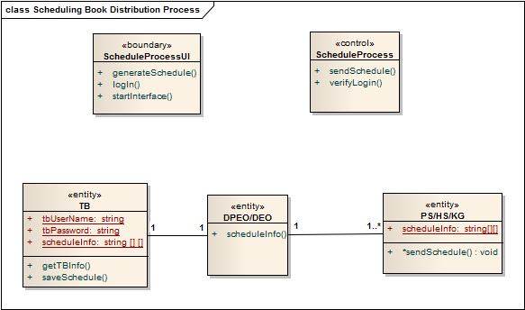

Collaboration Diagram:

